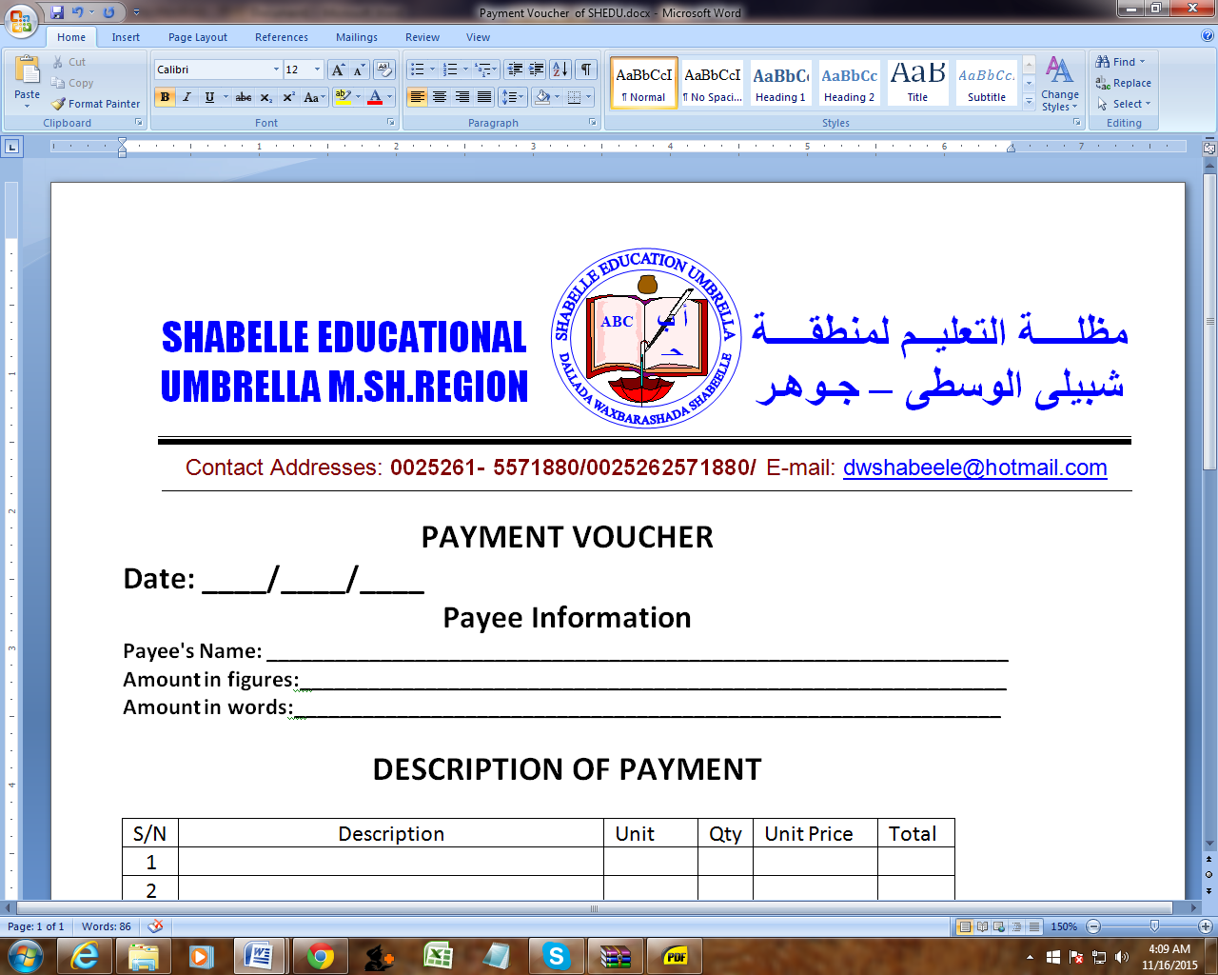

WASH Project Officer
Shabelle Education Umbrella-SHEDU
JOWHAR-Middle shabelle

The purpose of the WASH Project/Supervisor Officer position is to contribute with specific technical competences to project implementation. This position will normally not entail management responsibility of staff, but under certain circumstances the job may entail management responsibility for a very limited number of staff at assistant level. These circumstances can either be related to a time-bound support or permanent but in scope limited administrative support.

Duties and responsibilities
- Ensure smooth and quality implementation of work of contractors’ water supply activities e.g., installation, test pumping, installation of storage tanks and distribution networks (pipelines, tap stands, etc.).
- Ensure drilling and motorization reports compiled and shared with all stakeholders.
- Ensure system management and routine water quality monitoring with regular feedback, reporting, and precautionary measures taken to always ensure supply of treated/safe water.
- Ensuring that all planning processes and bill of quantities are in line with budget planning, budgetary constraints and in accordance with donor requirements.
- Provide guidance to the borehole operators, pump attendants and other water supply operators, on the mandatory procedures for preventive maintenance tasks. whenever necessary.
- Work with other team members, to contribute to the design, dissemination, and monitoring of field related activities.
- Ensuring that work schedules required for efficient programme implementation are implemented timely and as per agreed standards.
- Ensure capacity building and performance management for the relevant staff.
- Contribute to weekly WASH team planning meetings, preparation of integrated work plan and vehicle planning.
- Contribute to developing program activities, work plans, procurement plans and guide the implementation of WASH activities in an integrated approach.
- Provide regular and reliable narrative reports and weekly/bi-weekly reports.
- Manage the contractor’s work – set and agree their work and task in accordance with work plans, approaches and standards and provide technical guidance and support to ensure tasks and responsibilities are delivered.
- Maximize the value of integrated working with Sanitation and Hygiene Promotion team, finance, HR, and Logistics teams.
- Any other work as may be assigned by supervisor.

Qualifications.

- Bachelor of Science degree in Civil engineering, Water supply engineering, hydraulic engineering, or related engineering fields.
- Experience in a humanitarian (emergency) and development WASH programme preferably with an INGO.
- Previous experience from working in complex and volatile contexts.
- Documented results related to the position’s responsibilities.
- Excellent communication (spoken and written) skills, including the ability to explain and present technical information in English language.
- Proven practical experience in the planning and execution of WASH/Water and Sanitation Engineering Projects.
- Ability to initiate, develop, plan, and implement an integrated programme.
- Problem solving and analysis often involves difficult decision-making based on scenarios and unknown variables.
- Ability to work independently in a result oriented multi-tasking and multi-cultural environment and manage conflicting priorities.
- Proven ability to use MS Office software (especially Word and Excel) is essential. Experience with other computer programs such as AUTOCAD, EPANET and Microsoft Project would be an advantage.
- Knowledge of local language is highly desirable.

Personal qualities
- Planning and delivering results.
- Working with people.
- Communicating with impact and respect.
- Handling insecure environments.

How to apply
Your application should be sent to the below email address, please indicate the title of the position you have applied in the email subject by close of business 7th June 2023. It should include a cover letter & a detailed CV (hr@shedusom.org)

Only shortlisted candidates will be contacted.
NB. Female candidates are highly encouraged to apply.

