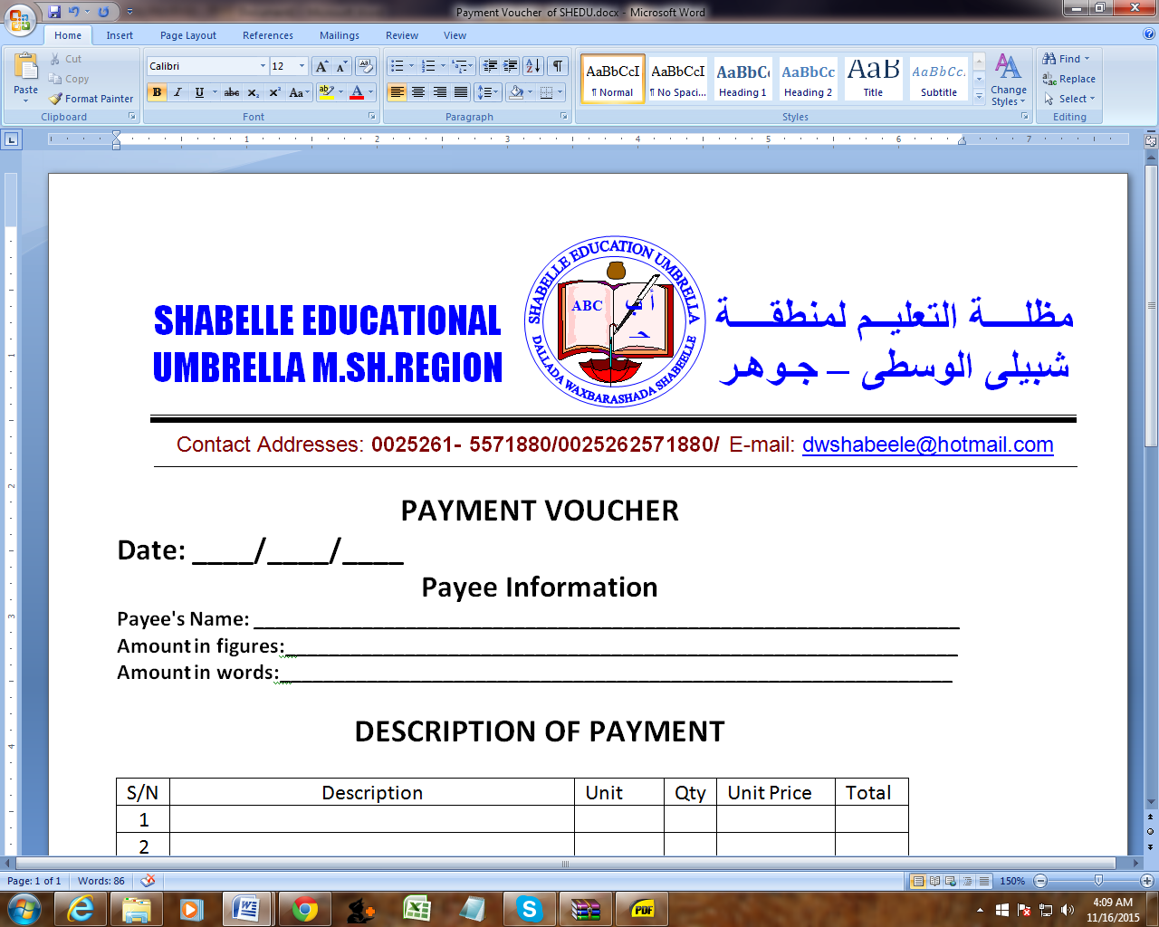

WASH Project Manager-7 months -Possibility of extension
Shabelle Education Umbrella-SHEDU
JOWHAR-Middle shabelle

Job Summary
The Water, Sanitation & Hygiene (WASH) Project Manager (PM) is responsible for running and supervising water, sanitation, and hygiene projects at all stages of the project management cycle. He/she is also responsible for accomplishing the project objectives and outcomes within the contextual constraints. The PM ensures the overall success of the project by making sure the WASH team completes the defined activities while adhering to internal standards and contractual obligations; and that the project is completed on time, within budget and with acceptable quality.
Further objectives for the WASH PM concern the capacity building and mentoring of staff; humanitarian needs identification through monitoring of the evolving situation; context analysis to contribute to the development of future projects including writing proposals; and internal coordination to reinforce SHEDU’s integrated approach. The WASH project manager reports to the Executive Director

Position Requirements
Child Protection Policy
Child abuse in all forms is unacceptable to SHEDU, which recognizes its responsibility to protect children from harm in all areas of its work. SHEDU is committed to ensuring a child-safe environment and is applying a zero-tolerance approach towards any kind of child abuse and exploitation.
Discrimination, Abuse and Harassment Policy
SHEDU expressly prohibits and will not tolerate any form of discrimination, abuse, harassment (sexual or otherwise), based upon race, ethnicity, religion, national origin, gender, age, sexual orientation, marital status, citizenship status, disability, or military status. SHEDU employees and related personnel must under no circumstances take part in any form of discrimination, harassment, or abuse (physical, sexual or verbal), intimidation or exploitation, or in any other way infringe the rights of others inside or outside SHEDU.
Applications are strongly encouraged from female candidate.
Bachelor’s degree in engineering or related field. Master’s degree preferred.
- Fluent in Arabic & English (strong written and verbal skills)
- Experience working in the Syrian context and/or a strong demonstrated understanding of the country context and the region.
- Leadership experience managing WASH Projects or a similar role in the relevant humanitarian and development sectors.
- At least 3-5 years’ experience in WASH Projects Management
- Travel availability: frequent visits to the field
- Largely independent performance of task within a given task-related scope of action and decision-making; alternative courses of action are possible.
- Disciplinary leadership of staff in several projects
- Experience with data management, especially in the analysis of large sets of data and in data illustration
- Experience with remote management
- Comprehensive understanding of the Syrian conflict and context
- Competence with MS Office applications, including Word, Excel, and Outlook
- Great presentation and communication skills
- Strong management skills
- Reporting skills
- Strong knowledge in budgeting.
- Ability to build the capacity of the team.
- Professional, motivated, open, creative, responsible, flexible, culturally sensitive.
- Responsibility
- Develop project plan, ensure its smooth implementation, and manage the team’s performance of project tasks and activities that may include, but are not limited to:
- Construction or rehabilitation of water and sanitation networks, gravity flow systems, wells, or boreholes.
- Implementation of latrines or other sanitation facilities.
- Hygiene promotion and education.
- Hygiene kits distribution.
- Solid waste management and Desludging.
- Water treatment.
- Water trucking and emergency water supply.
- Carrying out of assessments and post-implementation monitoring.
- Monitoring of sub-contractor work.
- Ensure appropriate design, construction, and implementation of WASH hardware according to technical standards, as well as proper maintenance and use of WASH equipment.
- Develop and ensure the use of appropriate techniques and materials for hygiene promotion and training.
- Manage the project budget through the passing of timely orders, the preparation of monthly forecasts, and the monitoring of expenditure.
- Track the progress of activities, ensure the collecting of project indicators, and provide on-time internal status reports and external donor reports.
- Identify and monitor risks, constraints, or escalating issues, and inform the hierarchy accordingly.
- Ensure that all data and information are updated, well organized, and easily accessible; and those lessons learned, and best practices are capitalized.
- Coordinate with other technical departments to ensure a common approach, synergy, and sharing of information.
- Represent SHEDU’s WASH program externally and collaborate/coordinate with local authorities, partners, and stakeholders.
- Analyze and report on the evolving humanitarian needs and provide clear recommendations for interventions.
- Participate in the development of new proposals.

How to apply
Your application should be sent to the below email address, please indicate the title of the position you have applied in the email subject by close of business 7th June 2023. It should include a cover letter & a detailed CV (hr@shedusom.org)

Only shortlisted candidates will be contacted.
NB. Female candidates are highly encouraged to apply.

